**Project Design Phase -I**

**Solution Architecture**

|  |  |
| --- | --- |
| Date | 13 Nov 2022 |
| Team ID | PNT2022TMID42977 |
| Project Name | SMART FARMER: IoT Enabled Smart Farming Application |

**1.The Different Soil Parameters like light Intensity, Temperature, Soil PH Sensor are sensed using different sensors and the obtained value is stored in IBM cloud.**

**2. The NL810 is a 16 pin Motor Driver IC Which can control a set of two DC motors Simultaneously in any direction. The NL810 is designed to provide bidirectional drive currents of up to 600mA at voltage from 4.5v to 36v.**

**3. Arduino UNO is used as a processing unit which processes the data obtained from sensors and weather data from weather API.**

**4.Node-RED is a programming tool for wiring together hardware devices, APIs and online services in new and interesting ways. It provides a browser based editor.**

**5.The MQTT protocol is followed for communication.**

**6. All the Collected data are provided to the user through a mobile application which was developed using MIT app inventor.**

**7. Open weather provides hyperlocal minute forecast, Historical data, current state and from short-term to annual and forecasted weather data. All data is available via industry standard APIs.**

**8. The user cloud make decision through an APP, whether to water the crop, depending upon the sensor values.**

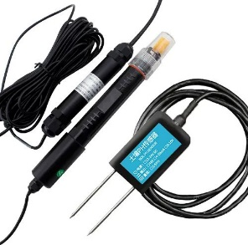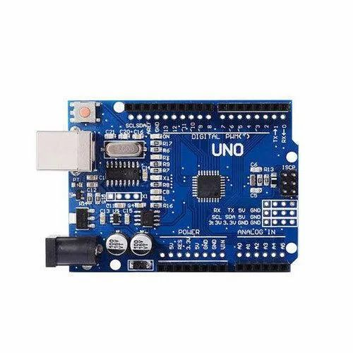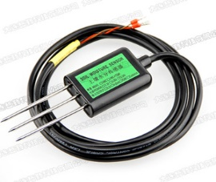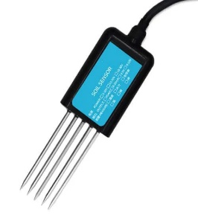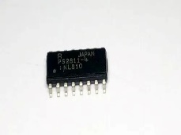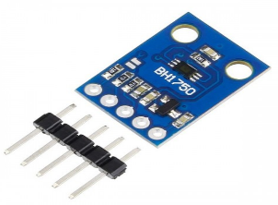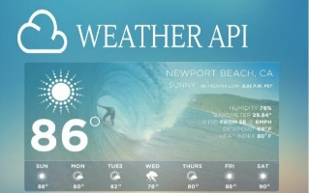**Solution Architecture Diagram** :

Temperature sensor

Soil Sensor

Mobile App

Soil PH Sensor

Weather API

Light Intensity Sensor

IBM Cloud

